Network Synchronization Specification

Author
Steven Kehrli (steveke)

Revision History
- 08/10/2000:
  - Initial Spec
- 08/11/2000:
  - Clarified clients and servers.
- 08/11/2000:
  - Tweaked NetsyncCreateServer() and NetsyncCloseServer().
- 11/16/2000:
  - Complete rewrite.
- 05/05/2001:
  - Changed enumeration and connection.
- 05/07/2001:
  - Added NetsyncRemoveClientFromSession().

- User Experience

Machine1 calls NetsyncCreateServer(). This function starts the netsync server.

Machine2 calls NetsyncEnumServers(). This function enumerates the available servers. Each enumerated server is passed in a call to the NetsyncEnumCallback function specified in the function call.

Machine2 calls NetsyncCreateClient(). This function creates the session client. On the netsync server (Machine1), the session server is created.

The session client (Machine2) may send messages to the session server (Machine1) or any other session client in the session (and vice versa), using NetsyncSendClientMessage().

The session client (Machine2) may receive client messages from the session server (Machine1) or any other session client in the session (and vice versa) using NetsyncReceiveClientMessage().

The session client (Machine2) may receive server messages from the netsync server (Machine1) using NetsyncReceiveServerMessage().

The session client (Machine2) may receive either type of message using NetsyncReceiveMessage().

Machine2 calls NetsyncCloseClient(). This function closes the session client.

Machine1 calls NetsyncCloseServer(). This function stops all running sessions and the netsync server.
- APIs

BOOL
NetsyncCreateServer(
)

Starts the server. This function is reference counted. Each call to NetsyncCreateServer() must be matched by a call to NetsyncCloseServer().

Return Values

If the function succeeds, the return value is nonzero. If the function fails, the return value is zero. To get extended error information, call GetLastError().

VOID
NetsyncCloseServer(
)

Decrement the server reference count. When the reference count reaches 0, the server is stopped.

VOID
NetsyncRemoveClientFromSession(
IN HANDLE hSessionObject,
IN HANDLE hNetsyncObject,
IN u_long ClientAddr
)

Remove the specified client from the session.

Parameters

hSessionObject
Handle to the session.

hNetsyncObject
Handle to the client object.

ClientAddr
Specifies the address of the client.

BOOL
NetsyncEnumServers(
IN DWORD dwSessionType,
IN LPVOID pSessionType,
IN PNETSYNC_ENUM_CALLBACK pNetsyncEnumCallback,
IN LPVOID lpContext
)

Enumerates the available servers.

Parameters

dwSessionType
Specifies the session type. It may be NETSYNC_SESSION_THREAD or NETSYNC_SESSION_CALLBACK. See 3) Session Types for more information.

pSessionType
Pointer to the session information. If dwSessionType is NETSYNC_SESSION_THREAD, pSessionType is treated as PNETSYNC_TYPE_THREAD. If dwSessionType is NETSYNC_SESSION_CALLBACK, pSessionType is treated as PNETSYNC_TYPE_CALLBACK. See 3) Session Types for more information.

pNetsyncEnumCallback
Pointer to a callback function:
typedef BOOL (*PNETSYNC_ENUM_CALLBACK) (
IN u_long ServerAddr,
IN BYTE bySessionClientCount,
IN u_short nServerClientCount,
IN BYTE bySessionCount,
IN LPVOID lpContext
);

Parameters

ServerAddr
Specifies the server address of the session.

bySessionClientCount
Specifies the number of clients in the session.

nServerClientCount
Specifies the number of clients on the server.

bySessionCount
Specifies the number of sessions on the server.

lpContext
Pointer to the context structure passed to NetsyncEnumServers.

The callback function is called once for each enumerated session. ServerAdd, bySessionClientCount, nServerClientCount, and bySessionCount will be specified.

The callback function is also called once per second. ServerAddr, bySessionClientCount, byServerClientCount, bySessionCount will be 0.

The callback function should return TRUE to continue enumeration. The callback function should return FALSE to stop enumeration.

lpContext
Pointer to a context buffer. lpContext is passed to each call to pNetsyncEnumCallback.

Return Values

If the function succeeds, the return value is nonzero. If the function fails, the return value is zero. To get extended error information, call GetLastError().

BOOL
NetsyncEnumCallback(
IN u_long ServerAddr,
IN BYTE bySessionClientCount,
IN u_short nServerClientCount,
IN BYTE bySessionCount,
IN LPVOID lpContext
);

Generic enumeration callback function exposed by Netsync. It returns the first session found.

When using NetsyncEnumCallback, pass a pointer to a NETSYNC_ENUM_SETTINGS structure as lpContext during the NetsyncEnumServers() call:
typedef struct _NETSYNC_ENUM_SETTINGS {
u_long ServerAddr;
DWORD dwTimeout;
} NETSYNC_ENUM_SETTINGS, *PNETSYNC_ENUM_SETTINGS;

Parameters

ServerAddr
Initialize to zero. On return, it will specify the server address of the session, or 0 if no session was found.

dwTimeout
Specifies the enumeration timeout, in seconds. A standard timeout would be 60 seconds.

HANDLE
NetsyncCreateClient(
IN u_long ServerAddr,
IN DWORD dwSessionType,
IN LPVOID pSessionType,
OUT u_short *LowPort,
OUT u_short *HighPort
)

Creates a client and joins it to a session.

Parameters

ServerAddr
Specifies the server address of the session.

dwSessionType
Specifies the session type. It may be NETSYNC_SESSION_THREAD or NETSYNC_SESSION_CALLBACK. See 3) Session Types for more information.

pSessionType
Pointer to the session information. If dwSessionType is NETSYNC_SESSION_THREAD, pSessionType is treated as PNETSYNC_TYPE_THREAD. If dwSessionType is NETSYNC_SESSION_CALLBACK, pSessionType is treated as PNETSYNC_TYPE_CALLBACK. See 3) Session Types for more information.

LowPort
Pointer to a buffer to receive the low port reserved for the session.

HighPort
Pointer to a buffer to receive the high port reserved for the session.

Return Values

If the function succeeds, the return value is a valid handle. If the function fails, the return value is ERROR_INVALID_HANDLE. To get extended error information, call GetLastError().

VOID
NetsyncCloseClient(
IN HANDLE hNetsyncObject
)

Removes a client from the session and closes it.

Parameters

hNetsyncObject
Handle to the client object.

DWORD
NetsyncSendClientMessage(
IN HANDLE hNetsyncObject,
IN u_long ToAddr,
IN DWORD dwMessageSize,
IN char *pMessage
)

Sends a message to another client in the session.

Parameters

hNetsyncObject
Handle to the client object.

ToAddr
Specifies the destination address. Specify 0 to send the message to the server.

dwMessageSize
Specifies the size of the message buffer, in bytes.

pMessage
Pointer to the message buffer.

Return Values

If the function succeeds, the return value is WAIT_OBJECT_0. If the function times out waiting for an ACK, the return value is WAIT_TIMEOUT. If the function fails, the return value is WAIT_FAILED. To get extended error information, call GetLastError().

DWORD
NetsyncReceiveServerMessage(
IN HANDLE hNetsyncObject,
IN DWORD dwTimeout,
OUT u_long *FromAddr,
OUT DWORD &dwMessageSize,
OUT char * *pMessage
)

Receives a server message.

Parameters

hNetsyncObject
Handle to the client object.

dwTimeout
Specifies the time-out internal, in milliseconds, to wait for a message.

FromAddr
Pointer to a buffer to receive the source address.

dwMessageSize
Pointer to a buffer to receive the size of the message buffer, in bytes.

pMessage
Address of the pointer to the message buffer.

Return Values

If the function succeeds, the return value is WAIT_OBJECT_0. If the function times out waiting for an ACK, the return value is WAIT_TIMEOUT. If the function fails, the return value is WAIT_FAILED. To get extended error information, call GetLastError().

Remarks

An application must call the NetsyncFreeMessage function to deallocate the message buffer.

DWORD
NetsyncReceiveClientMessage(
IN HANDLE hNetsyncObject,
IN DWORD dwTimeout,
OUT u_long *FromAddr,
OUT DWORD &dwMessageSize,
OUT char * *pMessage
)

Receives a client message.

Parameters

hNetsyncObject
Handle to the client object.

dwTimeout
Specifies the time-out internal, in milliseconds, to wait for a message.

FromAddr
Pointer to a buffer to receive the source address.

dwMessageSize
Pointer to a buffer to receive the size of the message buffer, in bytes.

pMessage
Address of the pointer to the message buffer.

Return Values

If the function succeeds, the return value is WAIT_OBJECT_0. If the function times out waiting for an ACK, the return value is WAIT_TIMEOUT. If the function fails, the return value is WAIT_FAILED. To get extended error information, call GetLastError().

Remarks

An application must call the NetsyncFreeMessage function to deallocate the message buffer.

DWORD
NetsyncReceiveMessage(
IN HANDLE hNetsyncObject,
IN DWORD dwTimeout,
OUT u_long *FromAddr,
OUT DWORD &dwMessageType,
OUT DWORD &dwMessageSize,
OUT char * *pMessage
)

Receives the first available server or client message.

Parameters

hNetsyncObject
Handle to the client object.

dwTimeout
Specifies the time-out internal, in milliseconds, to wait for a message.

FromAddr
Pointer to a buffer to receive the source address.

dwMessageType
Pointer to a buffer to receive the message type. It may be NETSYNC_MSGTYPE_SERVER or NETSYNC_MSGTYPE_CLIENT.

dwMessageSize
Pointer to a buffer to receive the size of the message buffer, in bytes.

pMessage
Address of the pointer to the message buffer.

Return Values

If the function succeeds, the return value is WAIT_OBJECT_0. If the function times out waiting for an ACK, the return value is WAIT_TIMEOUT. If the function fails, the return value is WAIT_FAILED. To get extended error information, call GetLastError().

Remarks

An application must call the NetsyncFreeMessage function to deallocate the message buffer.

- Session Types

  - NETSYNC_TYPE_THREAD

typedef struct _NETSYNC_TYPE_THREAD {
BYTE byClientCount;
u_short nMinPortCount;
LPWSTR lpszDllName_W;
LPSTR lpszMainFunction_A;
} NETSYNC_TYPE_THREAD, *PNETSYNC_TYPE_THREAD;

byClientCount
Specifies the number of clients required to start a session. This should be at least 1.

nMinPortCount
Specifies the minimum number of ports to reserve for the session.

lpszDllName_W
Pointer to a null-terminated string (UNICODE) that specifies the DLL to run the session.

lpszMainFunction_A
Pointer to a null-terminated string (ANSI) that specifies the function name to run the session. See NetsyncThreadFunction.

    - NetsyncThreadFunction

VOID
NetsyncThreadFunction(
HANDLE hNetsyncObject,
BYTE byClientCount,
u_long *ClientAddr,
u_short LowPort,
u_short HighPort
);

Parameters

hNetsyncObject
Handle to the client object.

byClientCount
Specifies the number of clients in the session.

ClientAddr
Pointer to an array of client addresses.

LowPort
Pointer to a buffer to receive the low port reserved for the session.

HighPort
Pointer to a buffer to receive the high port reserved for the session.

Remarks

NetsyncThreadFunction is responsible for running the session. It returns when the session is complete.

  - NETSYNC_TYPE_CALLBACK

typedef struct _NETSYNC_TYPE_CALLBACK {
BYTE byMinClientCount;
BYTE byMaxClientCount;
u_short nMinPortCount;
LPWSTR lpszDllName_W;
LPSTR lpszMainFunction_A;
LPSTR lpszStartFunction_A;
LPSTR lpszStopFunction_A;
} NETSYNC_TYPE_CALLBACK, *PNETSYNC_TYPE_CALLBACK;

byMinClientCount
Specifies the minimum number of clients required to start a session. This should be at least 1.

byMaxClientCount
Specifies the maximum number of clients supported by a session. This should be at least byMinClientCount; if not, it is silently set to byMinClientCount.

lpszDllName_W
Pointer to a null-terminated string (UNICODE) that specifies the DLL to run the session.

lpszMainFunction_A
Pointer to a null-terminated string (ANSI) that specifies the function name to handle each received message. See NetsyncCallbackFunction.

lpszStartFunction_A
Pointer to a null-terminated string (ANSI) that specifies the function name to call when starting the session. See NetsyncStartFunction.

lpszStopFunction_A
Pointer to a null-terminated string (ANSI) that specifies the function name to call when stoping the session. See NetsyncStopFunction.

    - NetsyncCallbackFunction

BOOL
NetsyncCallbackFunction(
IN HANDLE hNetsyncObject,
IN u_long FromAddr,
IN DWORD dwMessageType,
IN DWORD dwMessageSize,
IN char *pMessage,
IN LPVOID lpContext
);

hNetsyncObject
Handle to the client object.

FromAddr
Specifies the source address of the message.

dwMessageType
Specifies the message type. It may be NETSYNC_MSGTYPE_SERVER or NETSYNC_MSGTYPE_CLIENT.

dwMessageSize
Specifies the size of the message buffer, in bytes.

pMessage
Pointer to the message buffer.

lpContext
Pointer to the context buffer returned by NetsyncStartFunction().

Remarks

The server is responsible for running the session. The server is responsible for deallocating the message buffer. NetsyncCallbackFunction is responsible for handling the message. NetsyncCallbackFunction should return FALSE when the session is complete and no more messages should be received.

    - NetsyncStartFunction

LPVOID
NetsyncStartFunction(
IN HANDLE hNetsyncObject,
IN BYTE byClientCount,
IN u_long *ClientAddr,
IN u_short LowPort,
IN u_short HighPort
);

hNetsyncObject
Handle to the client object.

byClientCount
Specifies the number of clients in the session.

ClientAddr
Pointer to the array of client addresses.

LowPort
Specifies the low port reserved for the session.

HighPort
Specifies the high port reserved for the session.

Remarks

NetsyncStartFunction may return a pointer to a context buffer, lpContext. This pointer is passed to NetsyncCallbackFunction() and NetsyncStopFunction().

    - NetsyncStopFunction

VOID
NetsyncStopFunction(
IN HANDLE hNetsyncObject,
IN LPVOID lpContext
);

hNetsyncObject
Handle to the client object.

lpContext
Pointer to the context buffer returned by NetsyncStartFunction().

Remarks

NetsyncStopFunction should free any resources used by the session, such as lpContext.

- Session Behavior

When the server starts, it creates a server thread. This server thread acts as a message pump, listening for enumeration and connection requests.

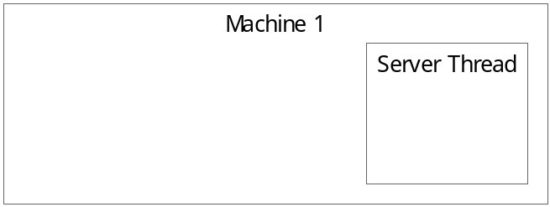

A second machine broadcasts an enumeration request. This request includes the desired session information. If the server understands the session information (i.e. it can load the specified DLL and functions), it responds to the request.

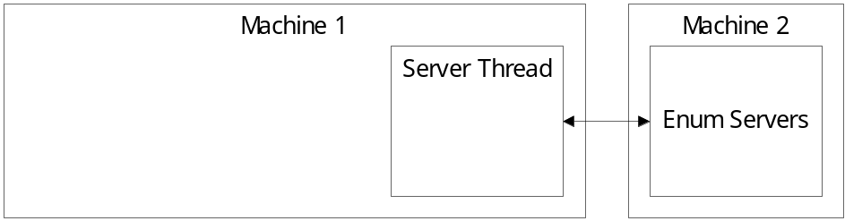

The second machine selects the desired server and sends the connect request. The server creates the desired session, if necessary, and adds the client to the desired session. When the session has the minimum number of clients, the server starts the session and responds to the client.

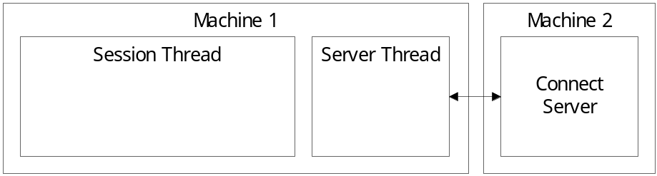

If the session type is SESSION_CALLBACK, the session thread first calls the start function. This function handles any initial setup of the session.

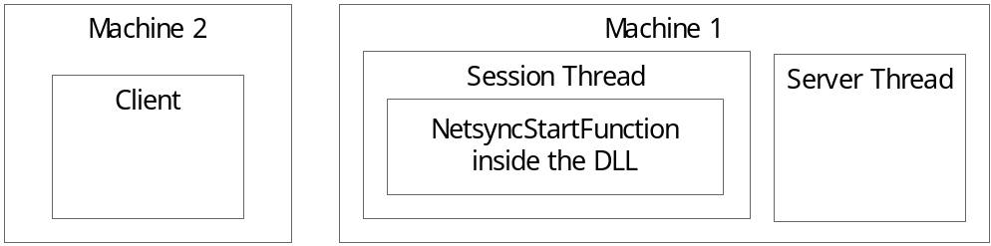

If the session type is SESSION_THREAD, the session thread calls the thread function. This function handles the session and returns when the session is complete.

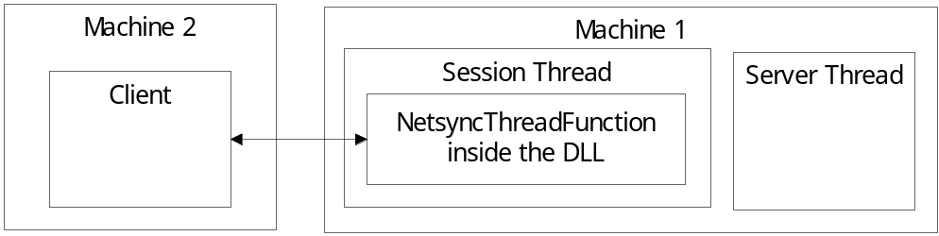

If the session type is SESSION_CALLBACK, the session thread then starts a receive message loop. Each received message is passed to the message function. This function returns FALSE when the session is complete.

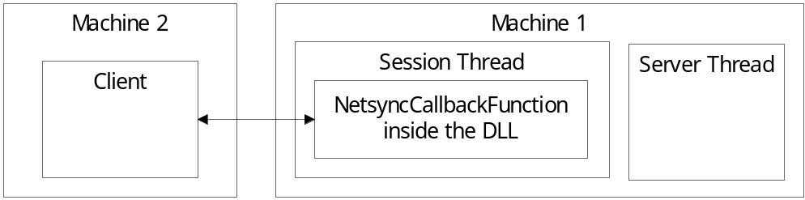

If the session type is SESSION_CALLBACK, the session thread calls the stop function. This function handles any final teardown of the session.

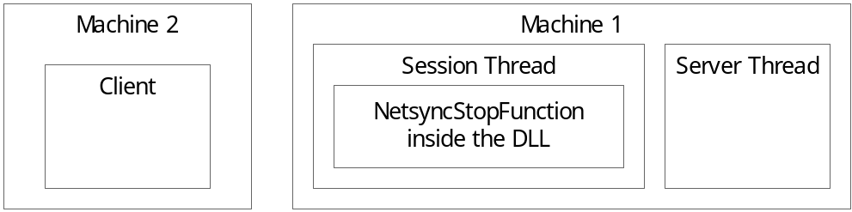

The session thread finally sends a message to each client in the session that the session has ended.

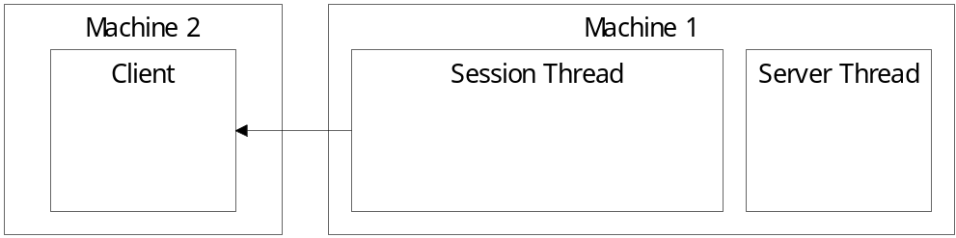

The session thread ends and the client should close.

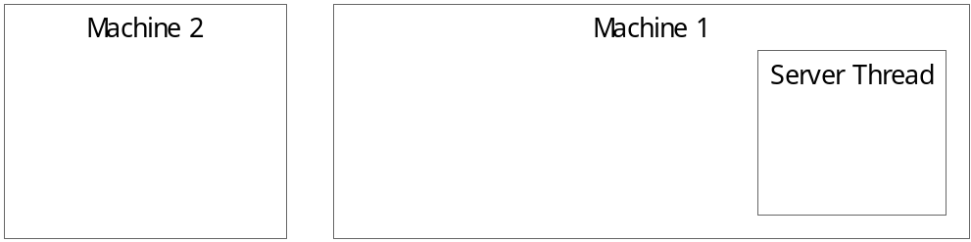

- Messages

A session is free to define its own messages. However, a message should conform to the following structure:
typedef struct _NETSYNC_GENERIC_MESSAGE {
DWORD dwMessageId;
} NETSYNC_GENERIC_MESSAGE, *PNETSYNC_GENERIC_MESSAGE;
That is, the first DWORD of the message buffer is the message id.

Each session should be aware of the following message ids:
NETSYNC_MSG_STOPSESSION
NETSYNC_MSG_ADDCLIENT
NETSYNC_MSG_DELETECLIENT
NETSYNC_MSG_DUPLICATECLIENT

NETSYNC_MSG_STOPSESSION is sent from the server to each session indicating the server is stopping. The session should exit as quickly as possible.

NETSYNC_MSG_ADDCLIENT is sent to the session indicating a client joined the session.
- If the session type is SESSION_THREAD, this message will not occur.
- If the session type is SESSION_CALLBACK, the client address is specified in the FromAddr parameter of the message function.

NETSYNC_MSG_DELETECLIENT is sent to the session indicating a client left the session.
- If the session type is SESSION_THREAD, the client address is returned in the FromAddr parameter of the receive function.
- If the session type is SESSION_CALLBACK, the client address is specified in the FromAddr parameter of the message function.

NETSYNC_MSG_DELETECLIENT is sent to the session indicating a client left the session.
- If the session type is SESSION_THREAD, the client address is returned in the FromAddr parameter of the receive function.
- If the session type is SESSION_CALLBACK, the client address is specified in the FromAddr parameter of the message function.

NETSYNC_MSG_DUPLICATECLIENT is sent to the session indicating a client rejoined the session without first leaving the session.
- If the session type is SESSION_THREAD, this message will not occur.
- If the session type is SESSION_CALLBACK, the client address is specified in the FromAddr parameter of the message function.

Each client should be aware of the following message ids:
NETSYNC_MSG_STOPSESSION

NETSYNC_MSG_STOPSESSION is sent from the session to each client indicating the session is stopping.

